**Name:** Prabir Tarafdar

**Roll No.:** 35000118051

**Dept.:** CSE 5th Sem

**Subject:** Computer Networks Lab

**Sub Code:** PCC-CS692

1. **A Client connected with the Server**

**server.py**

import socket               *# Import socket module*

s = socket.socket()         *# Create a socket object*

host = '192.168.0.7'  *# Get local machine name*

port = 6000            *# Reserve a port for your service.*

s.bind((host, port))        *# Bind to the port*

s.listen(5)                 *# Now wait for client connection.*

print(s)

print('server is ready')

while True:

    c, addr = s.accept()     *# Establish connection with client.*

    print('Got connection from', addr)

    c.send(**b**'Thank you for connecting')

    c.close()                *# Close the connection*

    break

s.close()

**client.py**

import socket               *# Import socket module*

s = socket.socket()         *# Create a socket object*

host = '192.168.0.7'  *# Get local machine name*

port = 6000                *# Reserve a port for your service.*

s.connect((host, port))

print(s.recv(1024))

s.close()                     *# Close the socket when done*

**Input/ Output:**

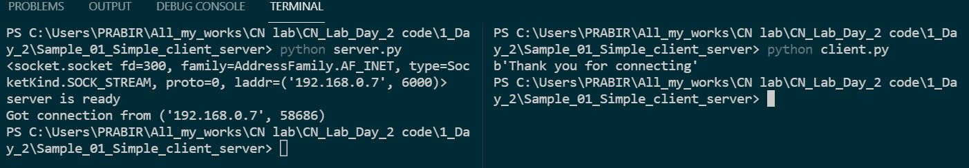

**2.Simple "Hello World" message received through server by the client:**

**Server_sock.py**

import socket

HOST = 'localhost'

PORT = 9999

s = socket.socket(socket.AF_INET, socket.SOCK_STREAM)

s.bind((HOST, PORT))

s.listen(1)

print(s)

print('server is ready')

conn, addr = s.accept()

print('connect by', addr, conn)

while 1:

    data = conn.recv(12)

    if not data:

        break

    conn.send(data)

conn.close()

**client_sock.py**

import socket

HOST = 'localhost'

PORT = 9999

s = socket.socket(socket.AF_INET, socket.SOCK_STREAM)

s.connect((HOST, PORT))

s.send(**b**'Hello, World')

data = s.recv(12)

s.close()

*# print 'Received', repr(data)*

print('Received-', data.decode())

**Input/Output:**

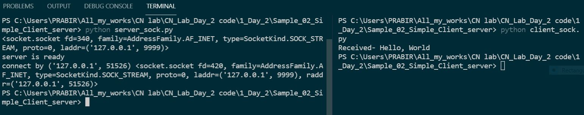

**3. A client received the server current running time, date, day:**

**sever.py**

import socket

import time

*# create a socket object*

serversocket = socket.socket(socket.AF_INET, socket.SOCK_STREAM)

*# get local machine name*

host = socket.gethostname()

port = 8000

*# bind to the port*

serversocket.bind((host, port))

*# queue up to 5 requests*

serversocket.listen(5)

print('Server is ready')

while True:

*# establish a connection*

    clientsocket, addr = serversocket.accept()

    print("Got a connection from - %s" % str(addr))

    currentTime = time.ctime(time.time()) + "\r\n"

    clientsocket.send(currentTime.encode('ascii'))

    clientsocket.close()

    break

serversocket.close()

**client.py**

import socket

*# create a socket object*

s = socket.socket(socket.AF_INET, socket.SOCK_STREAM)

*# get local machine name*

host = socket.gethostname()

port = 8000

*# connection to hostname on the port.*

s.connect((host, port))

*# Receive no more than 1024 bytes*

tm = s.recv(1024)

print("Time,Date and Day of the server: ", tm.decode())

s.close()

**Input/Output:**

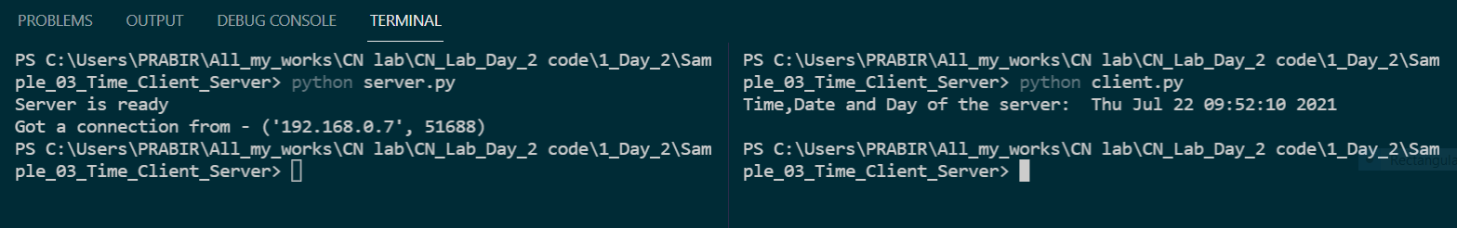

**4. Addition of three numbers by server and send It to client:**

**Server_add.py**

import socket

HOST = 'localhost'

PORT = 5008

s = socket.socket(socket.AF_INET, socket.SOCK_STREAM)

s.bind((HOST, PORT))

s.listen(3)

*# print s*

print('server is ready')

conn, addr = s.accept()

print('connect by', addr, conn)

while 1:

    data = conn.recv(1024)

    a, b, c = str(bytes(data), 'utf-8').split('+', 3)

    ans = int(a) + int(b) + int(c)

    conn.send(bytes(str(ans), 'utf-8'))

    conn.close()

    break

s.close()

**client_add.py**

import socket

HOST = 'localhost'

PORT = 5008

s = socket.socket(socket.AF_INET, socket.SOCK_STREAM)

s.connect((HOST, PORT))

s.send(bytes('20+12+10', 'utf-8'))

data = s.recv(1024)

print("Result = ", int(data))

**Input/ Output:**

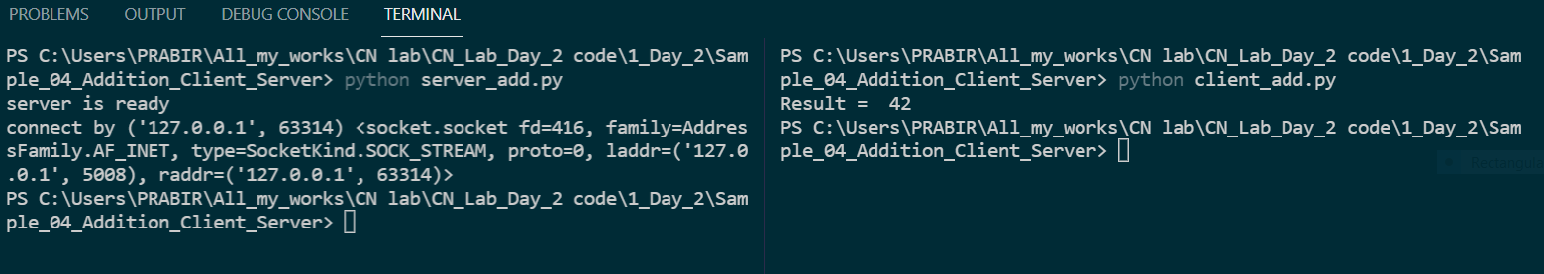

**5. Subtraction of three numbers by server and send it to client:**

**server_sub.py**

import socket

HOST = 'localhost'

PORT = 6008

s = socket.socket(socket.AF_INET, socket.SOCK_STREAM)

s.bind((HOST, PORT))

s.listen(3)

print('server is ready')

conn, addr = s.accept()

print('connect by', addr, conn)

while 1:

    data = conn.recv(1024)

    a, b, c = str(bytes(data), 'utf-8').split('-', 3)

    ans = int(a) - int(b) - int(c)

    conn.send(bytes(str(ans), 'utf-8'))

    conn.close()

    break

s.close()

**client_sub.py**

import socket

HOST = 'localhost'

PORT = 6008

s = socket.socket(socket.AF_INET, socket.SOCK_STREAM)

s.connect((HOST, PORT))

s.send(bytes('200-100-50', 'utf-8'))

data = s.recv(1024)

print("200 - 100 - 50 = ", int(data))

**Input/Output:**

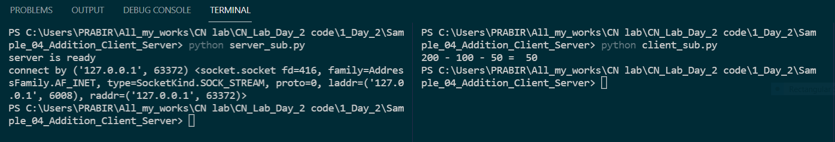

**6. Multiplication of three numbers by server and send it to client:**

**server_mul.py**

import socket

HOST = 'localhost'

PORT = 5008

s = socket.socket(socket.AF_INET, socket.SOCK_STREAM)

s.bind((HOST, PORT))

s.listen(3)

*# print s*

print('server is ready')

conn, addr = s.accept()

print('connect by', addr, conn)

while 1:

    data = conn.recv(1024)

    a, b, c = str(bytes(data), 'utf-8').split('*', 3)

    ans = int(a) * int(b) * int(c)

    conn.send(bytes(str(ans), 'utf-8'))

    conn.close()

    break

s.close()

**client_mul.py**

import socket

HOST = 'localhost'

PORT = 5008

s = socket.socket(socket.AF_INET, socket.SOCK_STREAM)

s.connect((HOST, PORT))

s.send(bytes('5*5*4', 'utf-8'))

data = s.recv(1024)

print("5*5*4 = ", int(data))

**Input/Output**

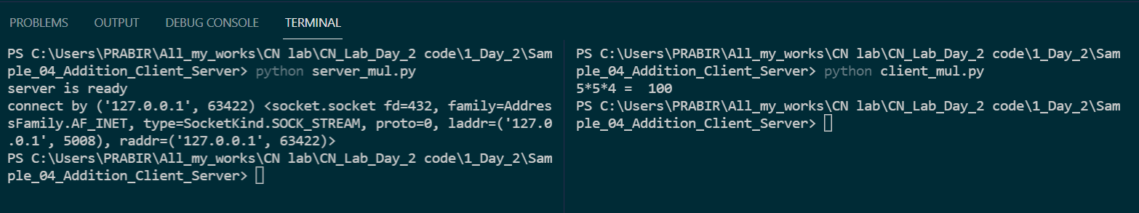

**7. Division of two numbers by server and send it to client:**

**server_div.py**

import socket

HOST = 'localhost'

PORT = 6666

s = socket.socket(socket.AF_INET, socket.SOCK_STREAM)

s.bind((HOST, PORT))

s.listen(3)

*# print s*

print('server is ready')

conn, addr = s.accept()

print('connect by', addr, conn)

while 1:

    data = conn.recv(1024)

    a, b = str(bytes(data), 'utf-8').split('/', 3)

    ans = int(a) / int(b)

    conn.send(bytes(str(ans), 'utf-8'))

    conn.close()

    break

s.close()

**client_div.py**

import socket

HOST = 'localhost'

PORT = 6666

s = socket.socket(socket.AF_INET, socket.SOCK_STREAM)

s.connect((HOST, PORT))

s.send('48/12'.encode())

data = s.recv(1024)

print("48 / 12 = ", data.decode())

**Input/Output**

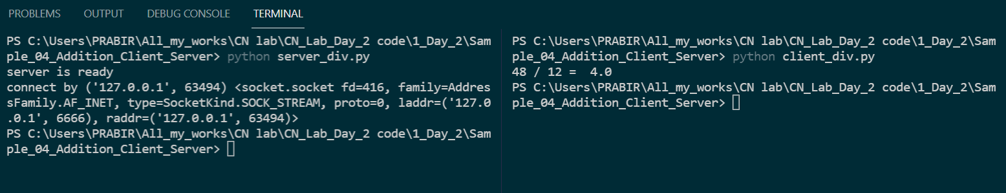

**8. client connect with the server and enter his/her name and get a connecting wish from server.**

**server.py**

import socket

host = '192.168.0.7'

port = 9999

s = socket.socket(socket.AF_INET, socket.SOCK_STREAM)

s.bind((host, port))

s.listen(5)

*# print(s)*

print('server is ready')

while True:

    c, addr = s.accept()

    name = c.recv(1024).decode()

    print("Connected With", addr, name)

    c.send(bytes(**f**'Thank you for connecting {name}', 'utf-8'))

    c.close()

s.close()

**client.py**

import socket

s = socket.socket(socket.AF_INET, socket.SOCK_STREAM)

host = '192.168.0.7'

port = 9999

s.connect((host, port))

name = input("Enter your name: ")

s.send(bytes(name, 'utf-8'))

print(s.recv(1024).decode())

s.close()

**Input/Output:**

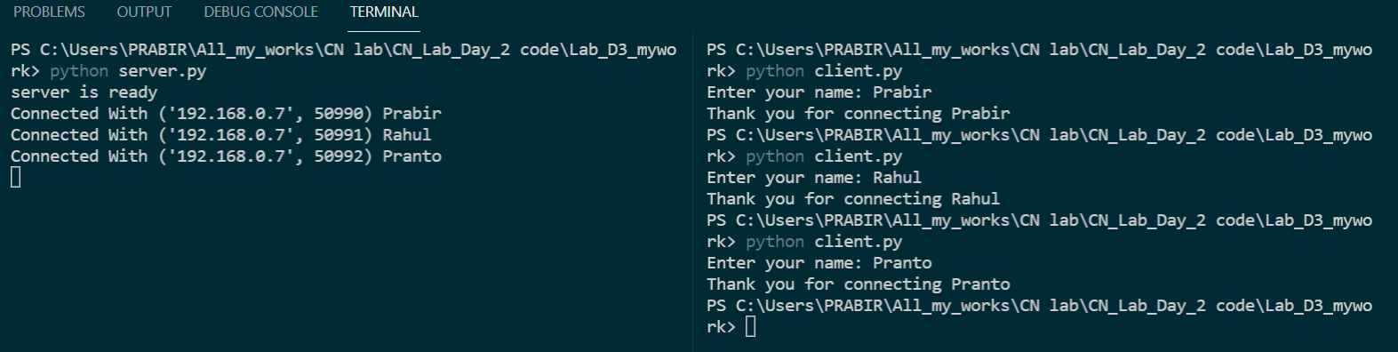

**9. client server calculator:**

**server_calculator.py**

*# @ Name: Prabir Tarafdar*

*# @ Date: 25/05/2021*

import socket

HOST = 'localhost'

PORT = 9999

s = socket.socket(socket.AF_INET, socket.SOCK_STREAM)

s.bind((HOST, PORT))

s.listen(5)

*# print s*

print('server is ready')

conn, addr = s.accept()

print('connect by', addr)

while True:

    data = conn.recv(1024).decode()

    tokens = data.split('#', 3)

    a = int(tokens[0])

    b = int(tokens[1])

    op = tokens[2]

    if op == '1':

        ans = a+b

    elif op == '2':

        ans = a-b

    elif op == '3':

        ans = a*b

    elif op == '4':

        if b != 0:

            ans = a/b

        else:

            conn.send(("Divisor should  not be 0").encode())

    conn.send(str(ans).encode())

    conn.close()

    break

s.close()

**client_calculator.py**

*# @ Name: Prabir Tarafdar*

*# @ Date: 25/05/2021*

**def** menuBar():

    Dict = {

        1: 'Addition',

        2: 'Substraction',

        3: 'Multiplication',

        4: 'Division'

    }

    for i in Dict:

        print(**f**"{i} : {Dict.get(i)}")

    k = input("Enter Your Choice : ")

    return k

if __name__ == "__main__":

    import socket

    HOST = 'localhost'

    PORT = 9999

    s = socket.socket(socket.AF_INET, socket.SOCK_STREAM)

    s.connect((HOST, PORT))

    op = menuBar()

    a = input('Enter the First No : ')

    b = input('Enter the Second No : ')

    c = a+'#'+b+'#'+op

    s.send(c.encode('ascii',))

    data = s.recv(1024)

    print('Result = ', data.decode())

    s.close()

**Input/Output:**

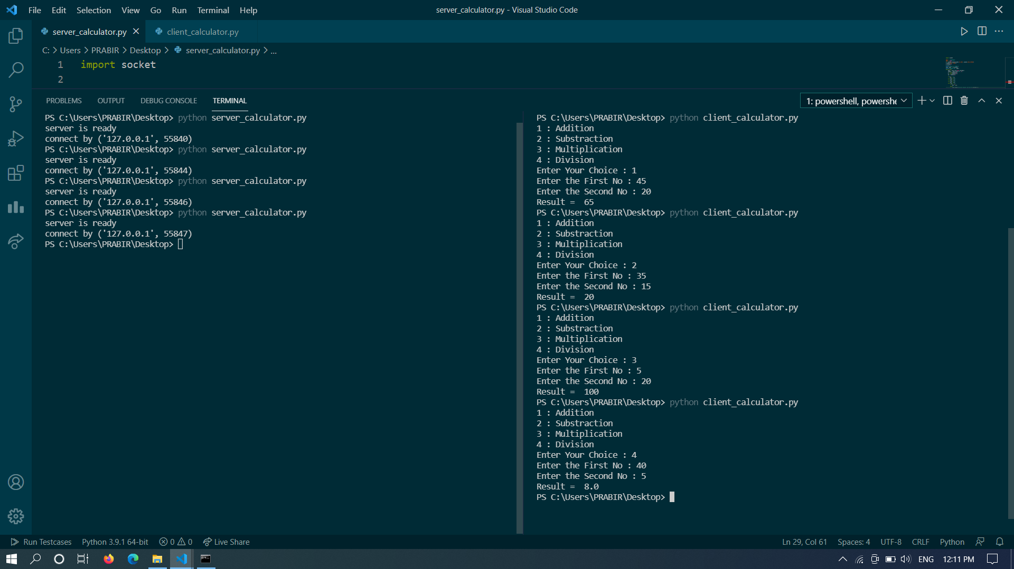

**10. Download and Upload - client server program:**

**down_up_server.py**

import socket

import os

HOST = 'localhost'

PORT = 5008

s = socket.socket()

s.bind(('', PORT))

s.listen(2)

print('FTP Server is ready....!!!')

conn, addr = s.accept()

print('connect by', addr)

itemList = os.listdir()

x = conn.recv(1024).decode()

if x == "1":

    conn.send(str(itemList).encode())  *# send present file list*

    keyfile = conn.recv(1024).decode()  *# receve the expected file name*

    if(keyfile in itemList):

        while (1):

            f = open(keyfile, "rb")

            l = f.read(1024)

            while(l):

                conn.send(l)

                l = f.read(1024)

                if len(l) == 0:

                    break

            print(**f**'{keyfile} - sent successfully..')

            f.close()

            break

        conn.close()

        s.close()

    else:

        conn.send("Not".encode())

        conn.close()

        s.close()

if x == '2':

    recvFileName = conn.recv(1024)

    f = open(recvFileName, "wb")

    l = conn.recv(1024)

    size = 0

    while(l):

        f.write(l)

        size += len(l)

        l = conn.recv(1024)

        if l == '':

            break

    print(**f**'file size={size/1024} KB  \n Receved successfully...')

    f.close()

    conn.close()

    s.close()

else:

    conn.close()

    s.close()

**down_up_client.py**

import socket

import os

HOST = '192.168.0.7'

PORT = 5008

s = socket.socket()

s.connect((HOST, PORT))

fileList = os.listdir()

print("Enter your choice")

t = input("1. Downloade\n2. Uploade\n")

s.send(t.encode())

if t == '1':

    serverFile = s.recv(1024).decode()

    print("\n Files Available in Server:\n")

    print(serverFile)

    file = input(

        '\n Enter the file Name whice you want to downloade (ex: abc.mp3)\n')

    s.send(file.encode())

    print('downloading.....')

    f = open(file, "wb")

    l = s.recv(1024)

    size = 0

    while(l):

        f.write(l)

        size += len(l)

        l = s.recv(1024)

        if l == '':

            break

    print(**f**'file size={ size/1024} KB  \n downloaded successfully...')

    f.close()

    s.close()

elif t == "2":

    print("Available Files...")

    for i in range(len(fileList)):

        if i > 0:

            print(fileList[i])

    infile = input(

        '\n Enter the file Name whice you want to Uploade (ex: abc.mp3)\n')

    s.send(infile.encode())

    if(infile in fileList):

        print('uploading.....')

        f = open(infile, "rb")

        l = f.read(1024)

        while(l):

            s.send(l)

            l = f.read(1024)

            if len(l) == 0:

                break

        print(**f**'{infile} successfully Uploaded')

        f.close()

        s.close()

    else:

        print(**f**"{infile} not present in your device!!")

        s.close()

else:

    print("Enter valid Option!!!")

    s.close()

**Input/Output:**

The file status **Before** doing anything**.**

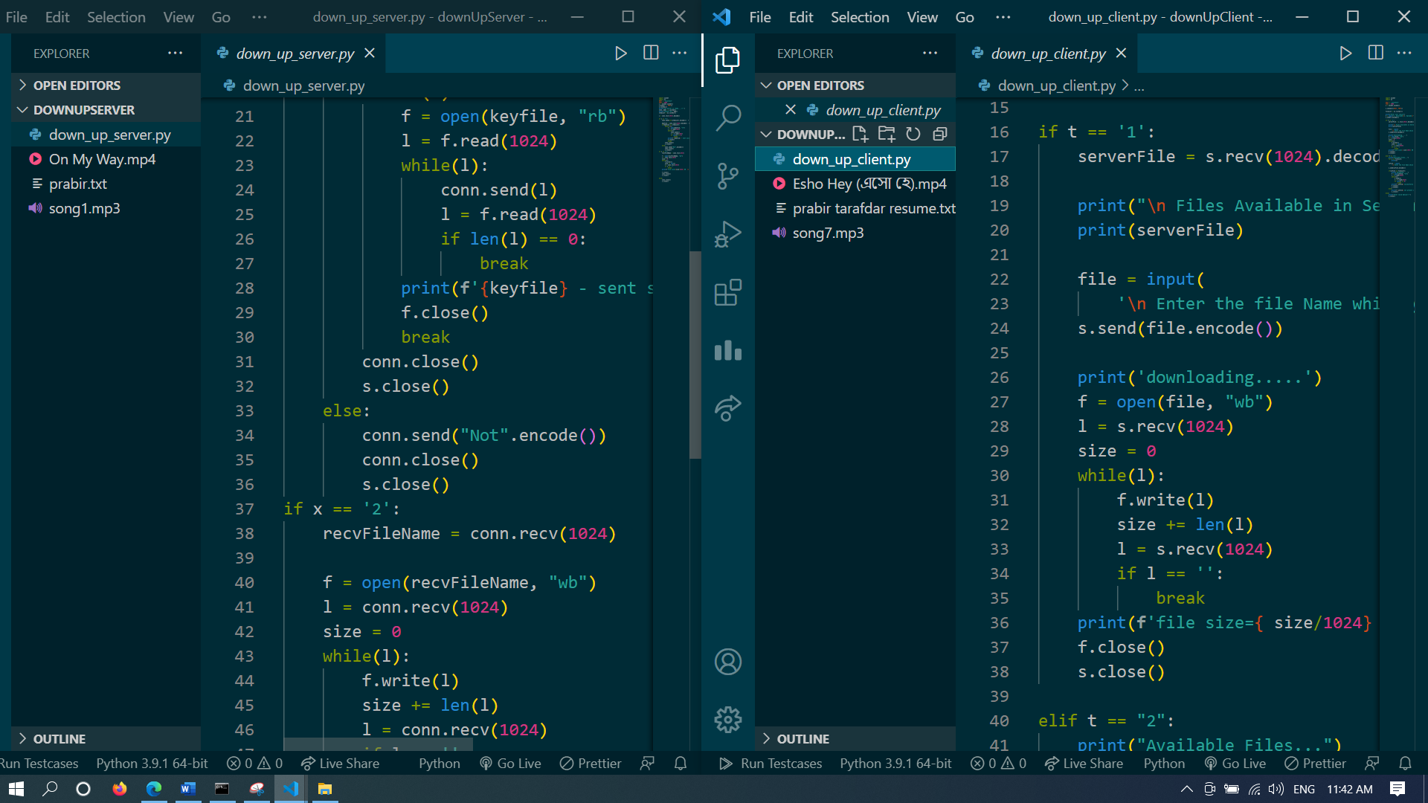

The file status **After** download and upload**.**

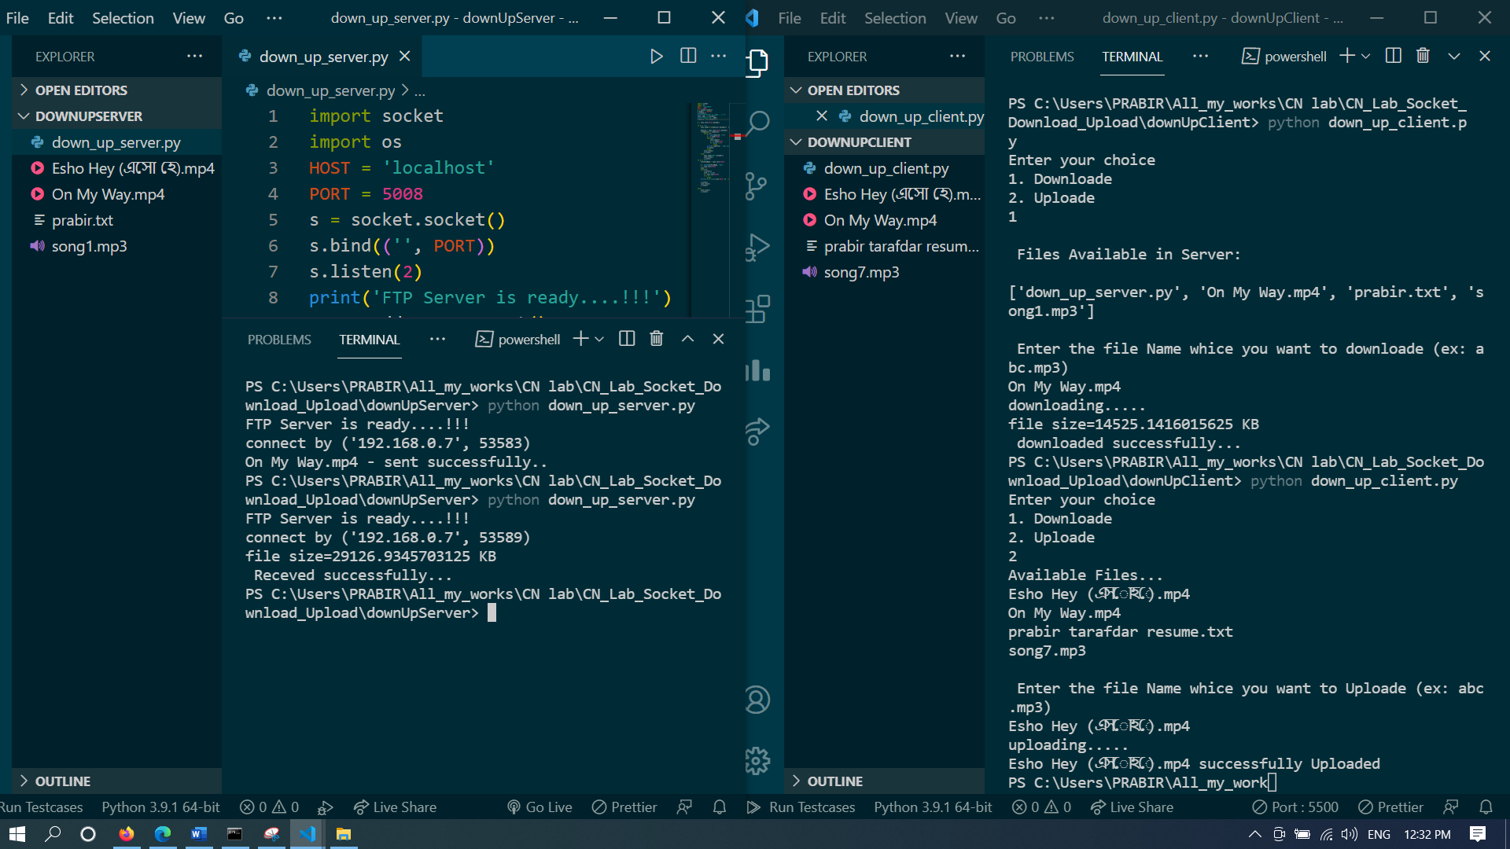

**11. Download using threade - client server program:**

Multiple clients can download same item at a time**.**

**Server.py**

import socket

from threading import Thread

*#from SocketServer import ThreadingMixIn*

TCP_IP = '192.168.0.7'

TCP_PORT = 8888

BUFFER_SIZE = 1024

**class** ClientThread(Thread):

**def** __init__(self, ip, port, sock):

        Thread.__init__(self)

        self.ip = ip

        self.port = port

        self.sock = sock

        print(" New thread started for "+ip+":"+str(port))

**def** run(self):

        filename = 'Nill Digonte.mp3'

        f = open(filename, 'rb')

        while True:

            l = f.read(BUFFER_SIZE)

            while (l):

                self.sock.send(l)

                l = f.read(BUFFER_SIZE)

            if not l:

                f.close()

                self.sock.close()

                break

tcpsock = socket.socket(socket.AF_INET, socket.SOCK_STREAM)

*#tcpsock.setsockopt(socket.SOL_SOCKET, socket.SO_REUSEADDR, 1)*

tcpsock.bind((TCP_IP, TCP_PORT))

threads = []

while True:

    tcpsock.listen(5)

    print("Waiting for incoming connections...")

    (conn, (ip, port)) = tcpsock.accept()

    print('Got connection from ', (ip, port), conn)

    newthread = ClientThread(ip, port, conn)

    newthread.start()

    threads.append(newthread)

**client.py**

import socket

TCP_IP = '192.168.0.7'

TCP_PORT = 8888

BUFFER_SIZE = 1024

s = socket.socket(socket.AF_INET, socket.SOCK_STREAM)

s.connect((TCP_IP, TCP_PORT))

size = 0

with open('Nill Digonte(download).mp3', 'wb') as f:

    print('file opened')

    while True:

        print('receiving data...')

        data = s.recv(BUFFER_SIZE)

*#print('data=%s', (data))*

        if not data:

            f.close()

            print('file close()')

            break

*# write data to a file*

        f.write(data)

print('Successfully get the file')

s.close()

print('connection closed')

**output:**

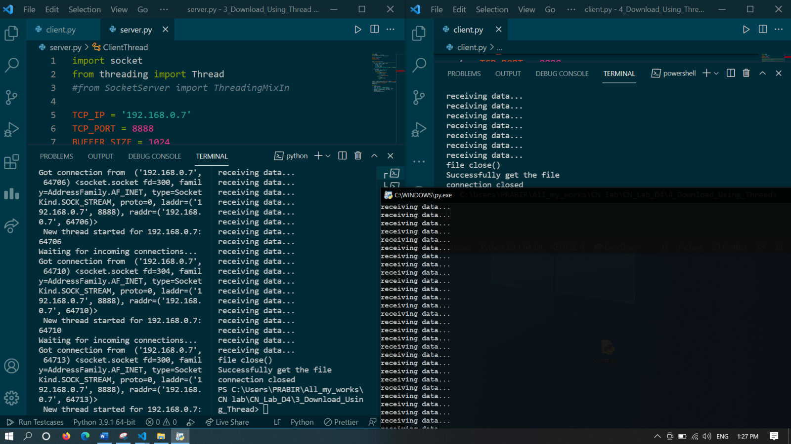

Client 3

Client 2

Client 1

**11. Simple chatroom between two clients through server.**

**Server.py**

import socket

HOST = '192.168.0.7'

PORT = 5555

s = socket.socket(socket.AF_INET, socket.SOCK_STREAM)

s.bind((HOST, PORT))

s.listen(20)

print("I am online..")

name = input("Enter your name: ")

name = "@"+name+">"

print("waiting...")

conn, addr = s.accept()

while 1:

    data = conn.recv(50)

    print("\t\t"+data.decode())

    print(" "+name+">>")

    string = input()

    msg = name+","+string

    conn.send(msg.encode())

    if data == "quit":

        break

    if string == "quit":

        break

s.close()

conn.close()

**client.py**

import socket

HOST = '192.168.0.7'

PORT = 5555

s = socket.socket(socket.AF_INET, socket.SOCK_STREAM)

s.connect((HOST, PORT))

name = input("Enter your name: ")

name = "@"+name+">"

print("now you can start your chat..")

while 1:

    print(name+">>")

    string = input()

    msg = name+","+string

    s.send(msg.encode())

    data = s.recv(50)

    print(data.decode())

    if data == "quit":

        break

    if string == "quit":

        break

s.close()

**Input/ Output:**

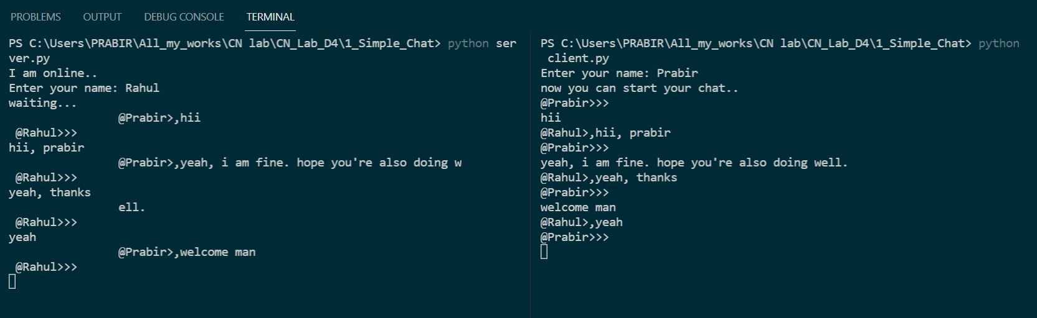

**12. A ChatRoom like WhatsApp group messaging (my project):**

Multiple clients can connect with a server and chatting with each other.

**Broadcasting** Mechanism is used here.

Server.py

import socket

import threading

*#host = socket.gethostbyname(socket.gethostname())*

host = '192.168.0.7'

port = 5000

server = socket.socket(socket.AF_INET, socket.SOCK_STREAM)

server.bind((host, port))

server.listen()

clients = []

fullNames = []

**def** broadcast(message):

    for client in clients:

        client.send(message)

**def** handle(client):

    while True:

        try:

            message = client.recv(1024)

            broadcast(message)

        except:

            index = clients.index(client)

            clients.remove(client)

            client.close()

            name = fullNames[index]

            broadcast(**f**'{name} left the chat!'.encode('ascii'))

            fullNames.remove(name)

            break

**def** receive():

    while True:

        client, addr = server.accept()

        print(**f**"connected with--{str(addr)}")

        client.send('NICK'.encode('ascii'))

        name = client.recv(1024).decode('ascii')

        fullNames.append(name)

        clients.append(client)

        print(**f**" Name of the client is: {name}")

        broadcast(**f**"{name} jioned the chat!".encode('ascii'))

        client.send('You are connected.Start chating '.encode('ascii'))

        thread = threading.Thread(target=handle, args=(client,))

        thread.start()

print("Server is running...")

receive()

client.py

import socket

import threading

client = socket.socket(socket.AF_INET, socket.SOCK_STREAM)

client.connect(('192.168.0.7', 5000))

name = input("Enter your name: ")

**def** receive():

    while True:

        try:

            message = client.recv(1024).decode('ascii')

            if message == 'NICK':

                client.send(name.encode('ascii'))

            else:

                print(message)

        except:

            print("[Error] Our team is working to fix it")

            client.close()

            break

**def** write():

    while True:

        message = **f**"{name}: {input()}"

        client.send(message.encode('ascii'))

receive_thread = threading.Thread(target=receive)

receive_thread.start()

write_thread = threading.Thread(target=write)

write_thread.start()

**Output:**

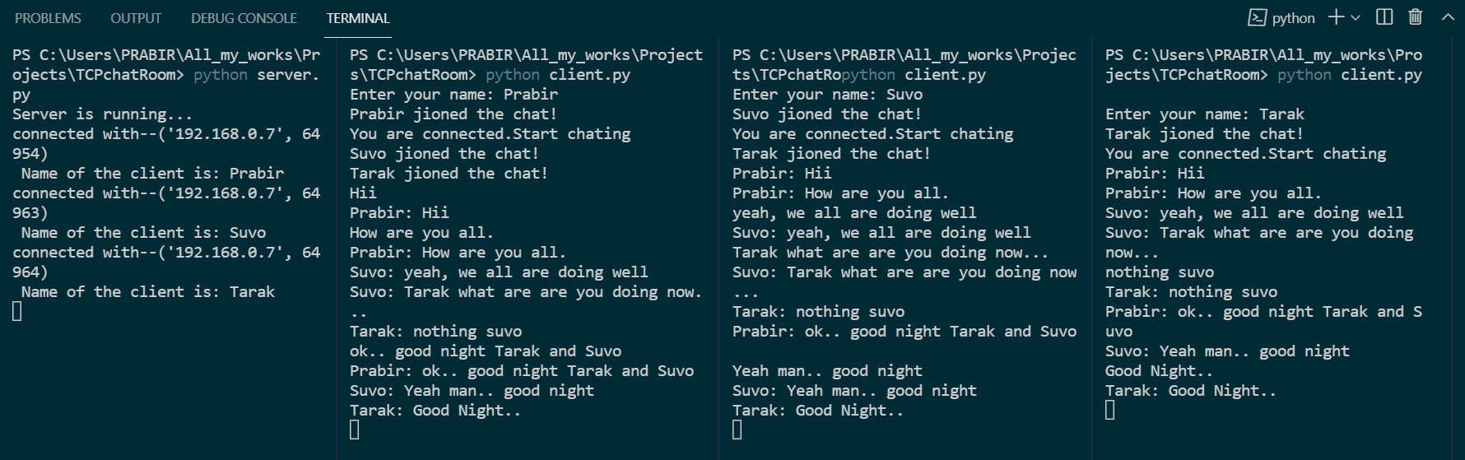

Thank You